**QUESTIONS**

**ON**

**RPA TECHNICAL ARCHITECTURE PROHRAM**

**Submitted By: Netlink Software Group America Inc.**

**Project Governance**

Netlink will follow the below Governance Model throughout the multiple phases of this project:

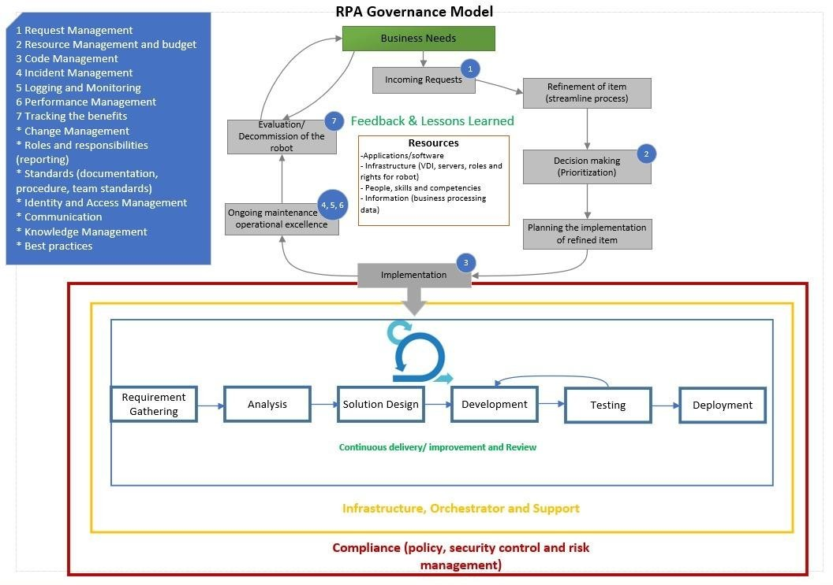

**Automation Implementation Methodology**

|  |  |  |  |
| --- | --- | --- | --- |
| **Stage** | **Role Involved** | **Key Task** | **Output** |
| **Kick Off** | •Solution Architect | •Set up the overall expectations of the project | • Reviewing the SOW |
| • Project Manager | • Early RPA readiness discussions about: | • Setting up communication |
| • Infrastructure Engineer | − Client’s environment and infrastructure | • Completing the customer readiness checklist |
|  | − Test and dev environments | • Initiating the Issue Tracker |
|  | − Test data/test cases |  |
| **Process Analyze** | •Solution Architect | • Analyze the chosen process in its as-is state and start the PDD | • Defining and finalizing the “to-be” process |
| • Project Manager | • Identify the degree of automation | • Completing and approving the PDD |
| • Business Analyst | • Streamline the business flow to the ‘to-be’ process | • Creating and approving the UAT plan |
|  | • Fill the PDD with the as-is and to-be processes |  |
| **Solution Design** | • Business Analyst | • Design a future state flow and maps out modules for automation development | • Completing the SDD document |
| • Solution Architect | • Use Application Tracker to record access required by the developer to build and run automation UAT and Production | • Completing the Application Tracker |
| • Project Manager | • Prepare the Technical Testing plan encompassing UAT scenarios, functional testing, and system integration testing | • Completing the Technical Testing Plan |
| • Automation Developers |  |  |
| **Development & Testing** | • Solution Architect | • Create the modules outlined in the design whiteboard using the PDD and SDD | • Building automation |
| • Project Manager | • Review and make necessary changes to the code | • Completing Unit and Integration Testing |
| • Automation Developers | • Test and run the modules individually in controlled settings | • Completing code review |
|  | • Execute the Technical Testing plan after Development and Unit Testing | • Executing Technical Testing plan |
|  | • Create automated tests for functional testing to confirm large functions independently |  |
|  | • Complete end-to-end test for system integration testing |  |
|  | • Run all UAT test scenarios |  |
| **User Acceptance Testing (UAT)** | • Business Analyst | • Conduct UAT in coordination with the implementation team | • Executing UAT Test Cases |
| • Solution Architect | • Run all the potential happy path and business exception scenarios | • Signing off client business team test execution |
| • Project Manager | • Ensure all agreed-upon scenarios are tested | • Completing the Run book document |
| • Automation Developers | • Log any deviations and fix that with the help of the Automation Team |  |
|  | • Create a Runbook document template with the following details: |  |
|  | − System architecture |  |
|  | − Production environments |  |
|  | − Operating instructions for automation |  |
|  | − Instructions to the operations, IT, and automation implementation team |  |
|  | • Document the Runbook template for every automation |  |
| **Deployment and Hypercare** | • Solution Architect | • Migrate the final process packages, libraries, and assets to the production Orchestrator | • Revising the Runbook document |
| • Project Manager | • Identify and address issues quickly using hypercare | • Completing production bug fixes |
| • Automation Developers | • Run and review production cases using hypercare |  |
|  | • Fix issues promptly and repush to production |  |
|  | • Initiate knowledge transfer during hypercare |  |
| **Project Closure** | • Business Analyst | • Confirm conformance of all services are made as per the contract | • Checking and signing off contract completion by the client |
| • Solution Architect | • Carry out the handover process for long-term support of the developed automations | • Initiating knowledge transfer and document handover |
| • Project Manager | • Check and close financial loops |  |
| • Automation Developers |  |  |
| • Business Team |  |  |